CSD3156 Lab6 Report

Student Name: Bryan Ang Wei Ze
Student ID: 2301397

Result 1: Please paste the screenshot in the box below.
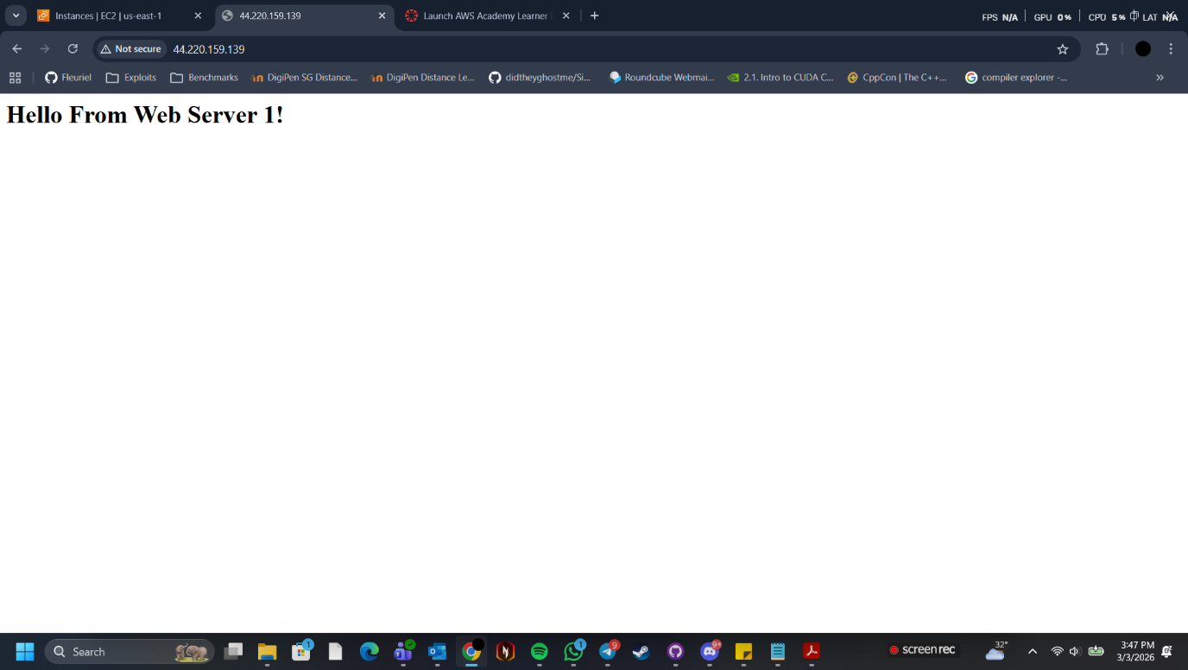

Result 2: Please paste the screenshot in the box below.
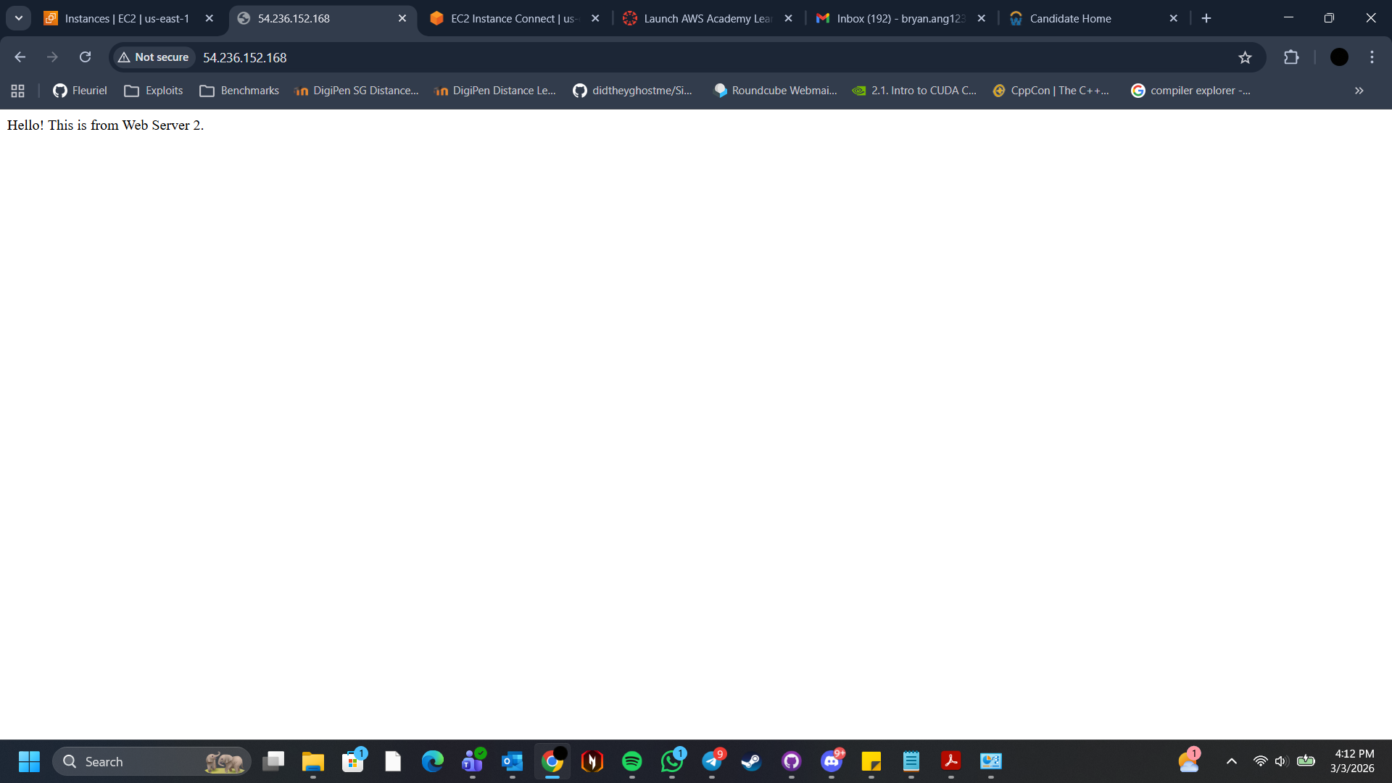

Result 3: Please paste the screenshot in the box below.
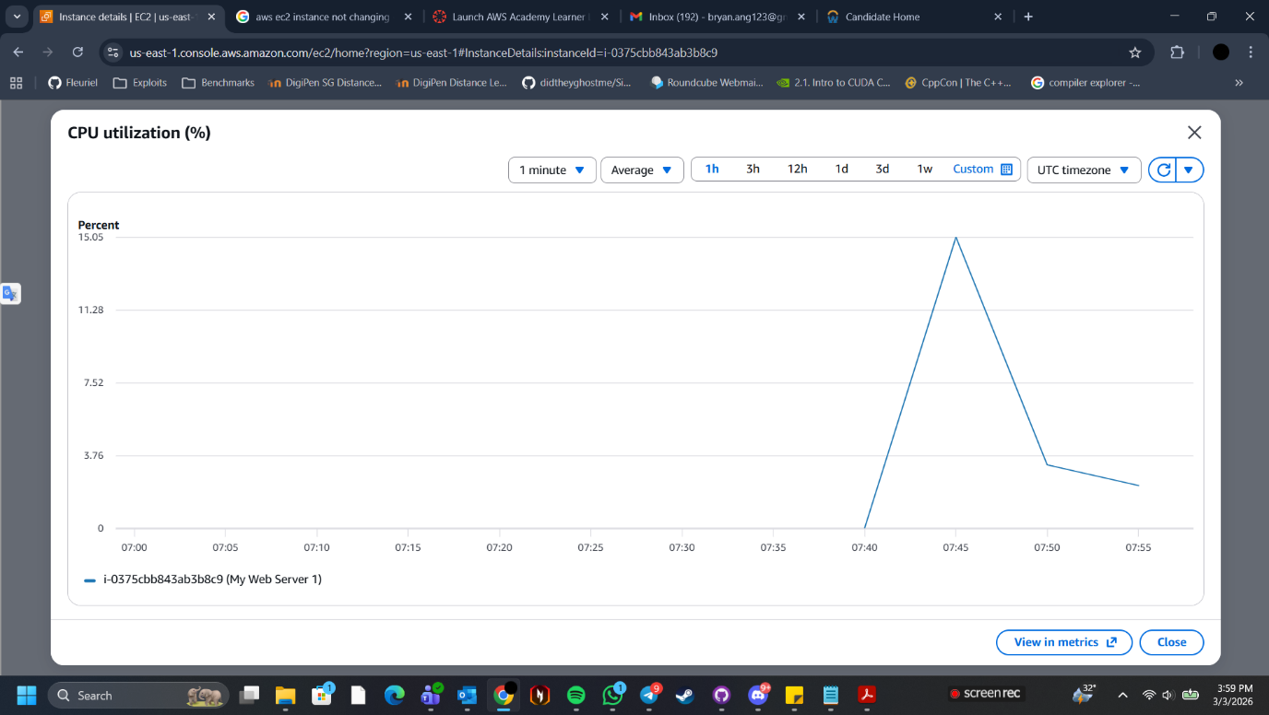

Result 4: Please paste the screenshot in the box below.
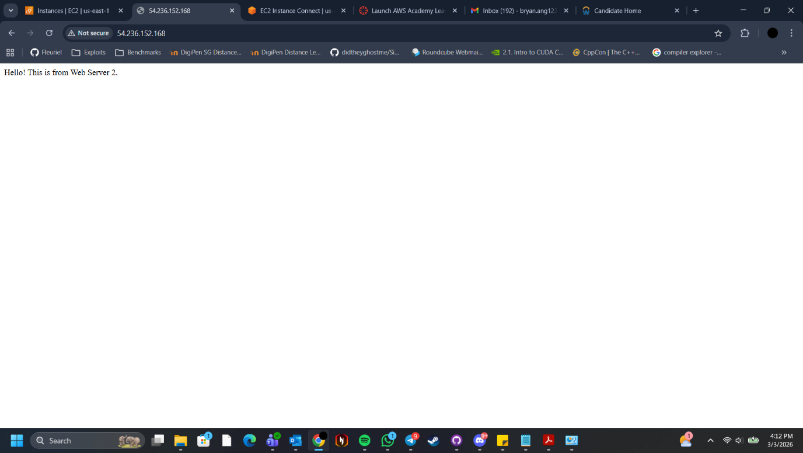

Reflection: Please add one or two lines on what you have learned.
Learned how to launch a web server, configuring the web server instance, monitoring performance of web server on various metrics and creating a microservice using Amazon Web Services

